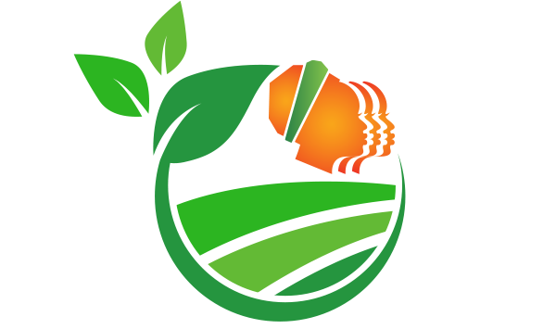
Live a Good Life!

African Women’s Collaborative for Healthy Food Systems

Steering Committee • Application Form

The African Women’s Collaborative for Healthy Food Systems is currently seeking to expand its Steering Committee with three committed and impact-driven young women leaders. These women will bring a new dynamic to the Collaborative and at the same time engage with other Steering Committee members and learn from the Collaborative’s work. The Collaborative is particularly seeking representation from Democratic Republic of Congo, Ghana, Nigeria, and South Africa. We welcome your expressions of interest to join this dynamic team, with an average of 3-6 hours per month. Please read our Terms of Reference to learn more about the role and criteria before filling this application form.

Your full name
Country of origin
Country of residence
Contact details:
Email
Cell phone
WhatsApp
Postal address
Organization you are currently affiliated with
Name:
Location and country:
Website:
Your title/role with the organization
Your date of birth
Your gender
Please provide a short biography of yourself; with key accomplishments and leadership roles (max. 150 words)
Please provide a short description of the organization that you work closely with, including its mission, values, membership, programs, and website (max 200 words)
What are your main responsibilities and activities within the organization?
What knowledge and experience do you have with regards to healthy food systems? Please describe briefly.
Do you have any relationship with food sovereignty movements? If yes, please list each one and give a short description.
What knowledge and experience do you have with regards to African rural women’s rights? Please describe briefly.
Do you have any relationship with women’s rights organizations and/or movements? If yes, please list each one and give a short description.
What other movements are you networking with? Please list each one and give a short description.
Please indicate which of the following communication systems you use regularly. Please provide brief notes of any challenges you face with each.
Cell phone: Yes/No
WhatsApp: Yes/No
SMS: Yes/No
Facebook: Yes/No
Twitter: Yes/No
Skype: Yes/No
Email: Yes/No
Word documents: Yes/No
Excel spreadsheets: Yes/No
PowerPoint: Yes/No
Google docs: Yes/No
Dropbox: Yes/No
Other (please be specific):
What languages do you know? Please list all
Speak | Read |  | Write
Would you be available for 3-6 hours a month as a member of the Steering Committee?
What factors might inhibit your participation?
Do you have the support and/or approval of your organization to do this Leadership work? If yes, would you be doing this work as part of your organizational responsibilities? Please explain.
Is your organization willing to confirm in writing that it supports your application? If yes, please provide the name, email address and phone number of the relevant person we can contact.
If funds are available to support travel and other activities, is your organization able to receive money from outside the country?
Yes / No

If yes, is your organization willing to share financial information about its income and expenditure? Please provide contact details of the person who can help with this information.
Yes / No
Contact details:
In your own words, please describe what interests you about being a member of the Steering Committee of the African Women’s Collaborative for Healthy Food Systems?
Please provide the name and contact details (email, telephone) of two trusted allies who can be contacted to speak about the importance of your leadership.
Date:

Please email the completed form to applicationscollaborative@gmail.com

Thank you!

